Software Design Fundamentals - Interfaces
# Source: AI Source: Provided by: [Data Path: Persons Table -> ID Column: 1, Name_En Column: Motasem Essam] -> From: [ChatGPT] on [1/23/2026]
Interfaces define how different components of a system communicate with each other without exposing internal details. They provide a contract that specifies what a component can do, not how it does it.
👉 Think of interfaces as doors between rooms—you know what’s inside the room and what you can use, but not the internal wiring.

🔑 Key Points
# Source: AI Source: Provided by: [Data Path: Persons Table -> ID Column: 1, Name_En Column: Motasem Essam] -> From: [ChatGPT] on [1/23/2026]
- Specify methods, inputs, and outputs without revealing implementation
- Promote loose coupling between components
- Enable mocking and testing
- Facilitate extensibility and maintainability
- Ensure consistency across modules

❌ Bad Example (No Interface)
# Source: AI Source: Provided by: [Data Path: Persons Table -> ID Column: 1, Name_En Column: Motasem Essam] -> From: [ChatGPT] on [1/23/2026]
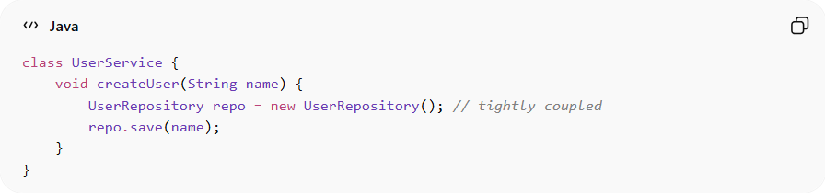
class UserService {
void createUser(String name) {
UserRepository repo = new UserRepository(); // tightly coupled
repo.save(name);
}
}
👉 Problems:
- Direct dependency on UserRepository
- Hard to replace, mock, or extend
- Violates dependency inversion principle

✅ Good Example (Using Interface)
# Source: AI Source: Provided by: [Data Path: Persons Table -> ID Column: 1, Name_En Column: Motasem Essam] -> From: [ChatGPT] on [1/23/2026]
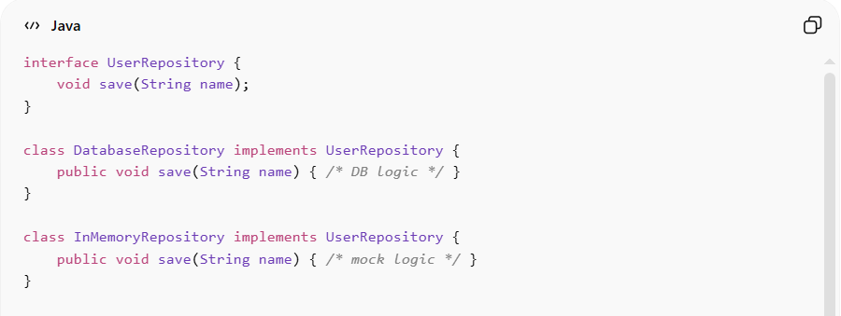
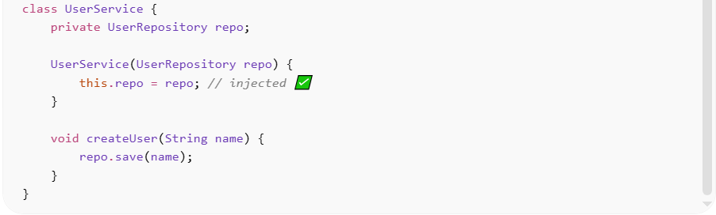
interface UserRepository {
void save(String name);
}

class DatabaseRepository implements UserRepository {
public void save(String name) { /* DB logic */ }
}

class InMemoryRepository implements UserRepository {
public void save(String name) { /* mock logic */ }
}

class UserService {
private UserRepository repo;

UserService(UserRepository repo) {
this.repo = repo; // injected ✅
}

void createUser(String name) {
repo.save(name);
}
}

✅ Benefits
# Source: AI Source: Provided by: [Data Path: Persons Table -> ID Column: 1, Name_En Column: Motasem Essam] -> From: [ChatGPT] on [1/23/2026]
- Loose Coupling → UserService doesn’t care how the user is saved
- Testable Code → can inject InMemoryRepository for tests
- Extensible → can add new storage types without changing UserService

💡 Summary
# Source: AI Source: Provided by: [Data Path: Persons Table -> ID Column: 1, Name_En Column: Motasem Essam] -> From: [ChatGPT] on [1/23/2026]
Interfaces define what a component can do while hiding how it does it, enabling flexibility, testability, and modularity.

